

May 2019
Dear family and friends:
I am going to serve “Stay Behind” children this summer as a camp counselor with China Service Ventures (CSV), in rural Henan Province. I have a chance to be a part of an international team of counselors from the US and China, and I hope that you will support me to raise money to sponsor Stay Behind children from rural China to camp. $100 sends one child to camp for four days and three nights.
First, I’d like to give you a brief overview of China Service Ventures (CSV), which has registered with the Chinese government a Henan Representative Office in Xinyang. CSV is authorized to serve the rural poor through five initiatives:
Enhancing Learning Environments and Providing Financial Aid
CSV establishes primary school libraries in rural Henan by purchasing books, shelving, tables, chairs, and lighting. A good book opens the creative mind of an inquiring student. Also, CSV provides financial aid to qualified “Stay Behind” children to help with school fees. These children are left behind with grandparents and/or relatives by their parents who seek work in other provinces. The parents may not be able to see their children except for once or twice a year. Our financial aid helps with room and board and sometimes clothing and school supplies so the child can stay in school. We call this scholarship program, “Bo Ai” (boundless love).
Provide Innovative Learning Activities for Stay Behind Children
This program serves Stay Behind children in rural primary and middle schools. CSV offers activities like personal care, peer mentoring, reading, tutoring, and basic social work services. Local University Volunteers assist us in this work and serve as positive role models for the younger students.
Facilitate Faculty and Student Exchanges
We offer our networks of contacts to facilitate faculty and student exchanges between the U.S. and China. Planned for the Year 2020 is a China House of Studies, which accommodates U.S. students and adults to participate in an intensive language immersion and learn Chinese history and culture taught by qualified Chinese teachers. Weekends will be devoted to travel and sight-seeing and testing newly discovered language skills.
Facilitate Cultural Programs and Summer Camps
In cooperation with Xinyang Radio and TV we offer an International Summer Camp experience for local and rural students in Xinyang County. Planned for 2020 are camps for 500 children. We also welcome short-term trips for professionals who would like to connect with their peers in China. We also facilitate a personalized “Hearts for Henan Tour” to acquaint prospective volunteers and donors with our work and with the local culture.

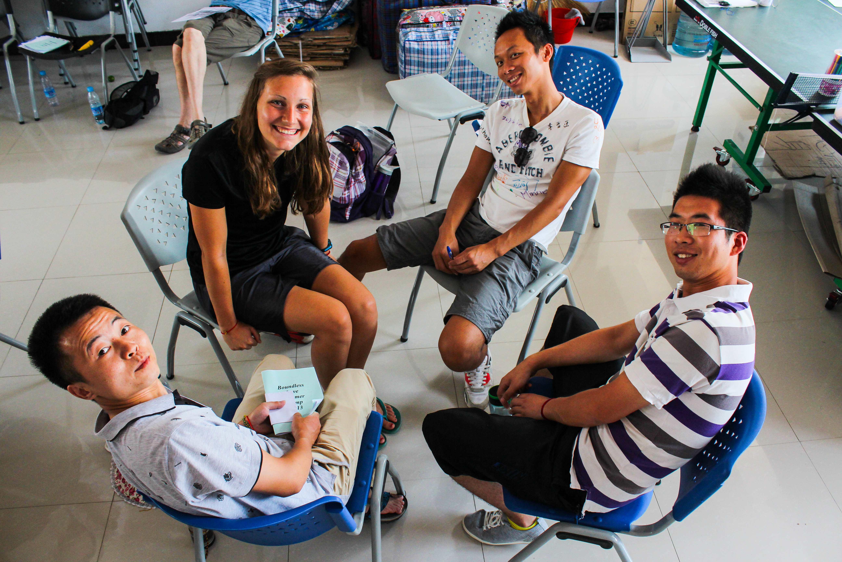
Summer Camp Experiences are Priceless! Many of CSV’s Stay Behind students and other youth will spend a week in camp with American counselors on Jigongshan “Rooster Mountain.” . In 2019, CSV will offer two camps, one for primary school students (ages 8-10) and one for middle school students (ages 11-15). Each camp session will have 50 students and last for four days and three nights. The intent is to build bridges of friendship between the U.S. and Chinese citizens in a safe, loving, and nurturing environment. CSV’s camp curriculum focuses on virtues, language learning, sports, arts & crafts, outdoor activities, fun group games, skits and dramas, and provides community service projects. A camp experience can have a profound positive and lasting effect upon the lives of children by reshaping their worldview, self-image, and life perspective.
I have been asked to raise $500, which will help sponsor five Stay Behind children to camp ($100 = 1 child). In addition, I am to cover my own passport, visa, travel insurance, and vaccination fees. My China expenses will be covered by CSV. If you would like to help defray their costs, you may also give to their organization.
You may pay me directly or you may go to CSV’s website www.chinaserviceventures.org and pay online. If you choose to send your payment to me it would be simplest to have you prepare a check made out to China Service Ventures and add a note: (NAME) Counselor Support. If you would like a tax deductable receipt from CSV please add a note and include your return address or email. If you choose to pay through CSV’s website please click on Donate Now and follow the instructions. As you enter your donation information you will come to a place where you may choose either Other Comments or Gift given in honor of and fill-in my name along with Counselor Support.
Thank you for empowering me to serve the Stay Behind children in China.
(your name and signature)

PS. China Service Ventures is a registered 501c3 nonprofit organization. If you choose to give a gift, they will acknowledge it and issue a receipt for your tax-deductible gift. Thank you!

